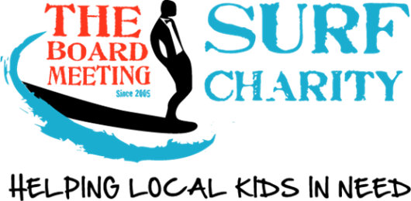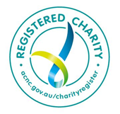

QLD CHARITY NO. CH1741 ABN 89 901 429 379

Application for Funding Assistance

**Basic criteria for funding includes:**

* Age – must be under 18 years of age.
* Location – must be a resident of the Sunshine Coast region* or where the chapter operates.
* Financial status – the family must have exhausted all other avenues including personal funding.
* Medically diagnosed disability or mental health issue.

At the committee’s discretion, support may be in the form of provision of goods/ services; or the direct payment of invoices made out to “The Board Meeting Charity” for the supply of goods/services to the nominated beneficiary.

Please attach all relevant quotes/invoices, medical reports, photo of the child & any other relevant documents.

**Please provide documentation from a healthcare provider verifying the child's disability or mental health issue.**

|  |  |  |  |
| --- | --- | --- | --- |
| **Referral Details** | | | |
| **Date** | |  | |
| **Submitted By** | |  | |
| **Occupation & Company** | |  | |
| **Contact Number** | |  | |
| **Email Address** | |  | |
| **Family Details** | | |
| **Beneficiary Name** |  | |
| **D.O.B** |  | |
| **Parent/ Guardians name** |  | |
| **Parent/ Guardians contact**  **(Phone and email)** |  | |
| **Does the family consent to have the child’s details made public?** |  | |
| **Family’s financial situation?**  **(Are they able to fund it themselves?)** |  | |
| **Residential Address** |  | |
| **Child’s Details** | | |
| **Medical Condition/s**  Please give reasonable detail around the child’s disability or mental health issue.  Please **provide documentation** from a healthcare provider verifying the child's disability or mental health issue. |  | |
| **Item/s Requested** |  | |
| **How item/s will improve child’s health/wellbeing** |  | |
| **Approximate Price of item**  *\* Quote/invoice to be sent* |  | |
| **Goods Supplier** |  | |

Please complete and return to [info@theboardmeeting.org](mailto:info@theboardmeeting.org) with requested documents.

We will now proceed to go through the approval process to make payment to.

It may take some few days to get completed.

Thank you.

